27. Develop a system using UML for Supermarket Management System. The system should maintain the stock detail, employee detail, and customer details. The system should intimate the product with low stock and nearing the expiry date. The loyalty feature of the customers should be maintained. The offers to the customers should be based on their loyalty features.

Class diagram

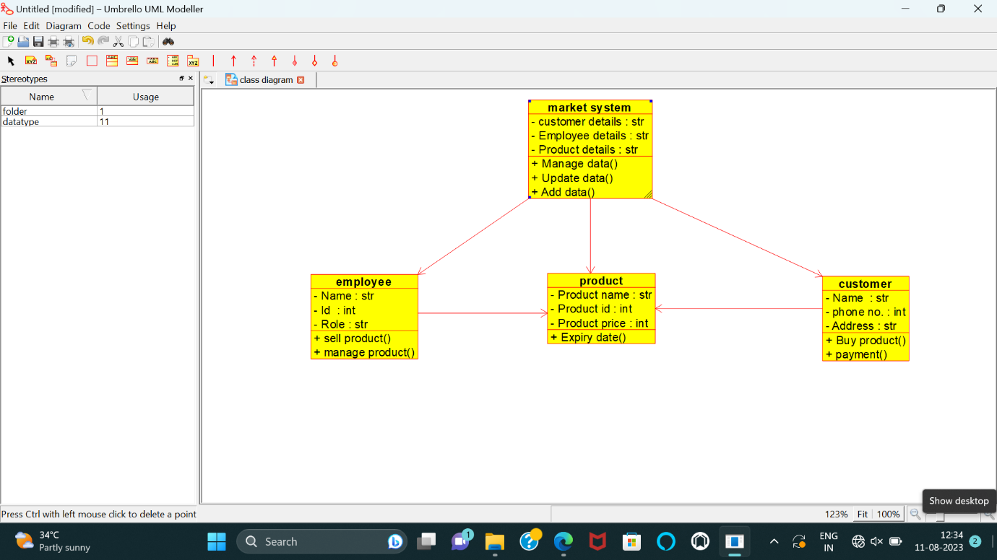

Use-case diagram

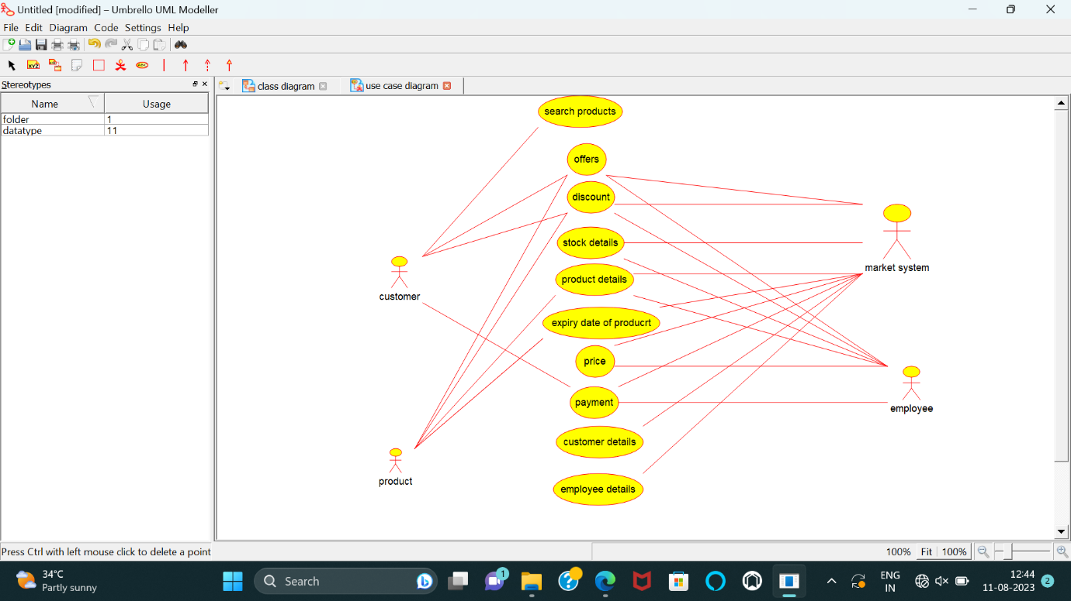

Activity diagram

